**Practical in CINeMA: Evaluating the confidence in network meta-analysis**

# **Analgesics as maintenance therapy for reducing pain in patients with cancer**

The data to be used for this example come from a systematic review used to inform WHO guidelines for treatments to reduce pain in patients with cancer. The PICO is as follows:

**Patients**: with (any) cancer in need of analgesic treatment as maintenance therapy

**Interventions**: any analgesic

**Control**: any analgesic or placebo

**Outcome**: pain relief as continuous outcome (change in a pain scale)

The systematic review identified 13 studies examining 12 treatments. The network plot is shown below.

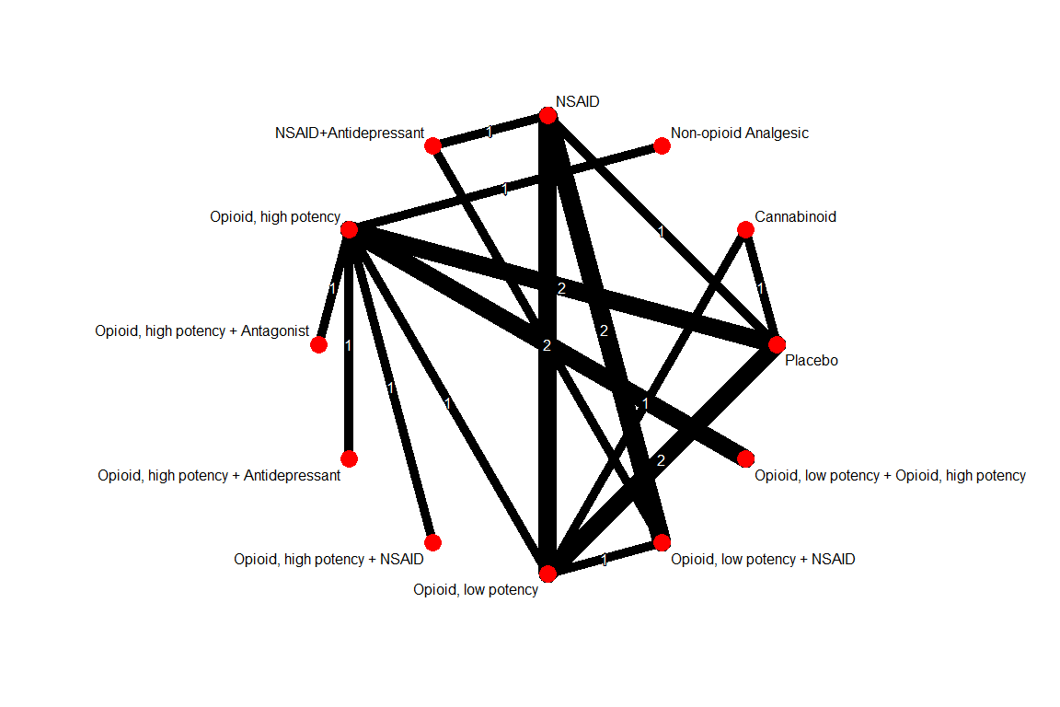

The interventions have been re-named in the data set as follows

Opioid high potency: Ohigh

Opioid low potency: Olow

Antidepressant: Ant

Non-opioid Analgesic: nO

Antagonist: Anta

Cannabinoid: Cannab

The estimated standardized mean differences using a random-effects NMA model are given in Table 1 at the end of the document. The aim of this exercise is to characterize each NMA treatment effect as pertaining to **high**, **moderate**, **low** or **very low quality of evidence.** The five GRADE domains will be considered: **study limitations**, **inconsistency**, **indirectness**, **imprecision** and **publication bias**. First, look at each one of the five domains and judge each NMA treatment effect. Then, for each NMA treatment effect, combine your judgements across domains to form an overall rating. **Highlight each cell in table 1 to reflect your final judgements.** CINeMA will be used to facilitate the process. Go to <http://cinema.ispm.ch> and upload the data ‘pain.csv’. In the configuration tab, select ‘random effects’, ‘Standardized Mean Difference’ and all treatment comparisons to reproduce the results in Table 1.

**Forming judgements requires additional information per domain and assumptions. Below we provide you with some insights and detailed instructions. Please do read the information before drawing conclusions.**

**Study limitations**: Studies have been evaluated by the systematic review team with respect to random sequence generation, allocation concealment, blinding of participants, blinding of outcome assessors, attrition bias and additional biases. These considerations have been summarized in a column named ‘rob’ in the data pain.csv where 1 indicates low risk of bias, 2 moderate and 3 high risk of bias.

*Consider coloring the nodes and edges of the network plot according to the risk of bias of studies to get a sense of the distribution of risk of bias in the network.*

*How will you synthesize the risk of bias assessments across studies to derive summary risk of bias per direct comparison?*

*After inspecting the bar chart showing the contribution of direct comparisons at low, moderate and high risk of bias to each NMA treatment effects, decide how you will summarize each bar. You may choose one of the pre-programmed summaries or make a customized rule e.g. with respect to the percentage of high risk of bias evidence.*

**Imprecision**: Importance of imprecise treatment effects depends on whether their confidence intervals include values that could lead into different clinical decisions.

*What range of values (on a standardised mean difference scale) would you suggest that are clinically non-important? Which values do you think are important? Inspect whether confidence intervals extend into clinically important effects in one or both directions.*

**Inconsistency – heterogeneity**: Importance of heterogeneity depends on the variability of effects in relation to a clinically important size of effect.

*Inspect the decisions provisionally made in the domain ‘heterogeneity’ with respect to the agreement of confidence and prediction intervals in relation to clinically important effects. Consider a) the estimated value of between-study variance from NMA and b) the between study-variances for each direct comparison along with reference intervals and decide whether you wish to change heterogeneity judgements.*

**Inconsistency – incoherence**: Both local and global tests should be considered when judging incoherence in NMA.

*Consider the results of the design by treatment interaction model (2,3) (global assessment of incoherence) and the side splitting approach (4) (local assessment of incoherence). Additionally to the p-values of the tests, which are used to prepopulate the judgements, consider also the magnitude of incoherence in relation to the direct and indirect treatment effects.*

**Indirectness**: According to the systematic review team there were not concerns regarding differences in the populations among studies as the eligibility criteria were adequately strict. The outcome “pain reduction” was, in some studies, not adequately defined. Limitations in the outcome definition were classified in three levels: ‘no limitations’, ‘some limitations’ and ‘highly atypical’. These considerations have been summarized in a column ‘indirectness’ in the data where 1 indicates no limitations, 2 some limitations and 3 highly atypical.

*How do you think that transitivity considerations are taken into account using the implemented approach?*

**Publication bias**: According to the systematic review team, it is unlikely that either important studies have been missed or studies have been performed but not published. However, the threat of publication bias is always possible despite the quality of the search strategy.

*Would you draw funnel plots to assess the risk of publication bias?*

***To summarize your judgements, consider copying and pasting the report table from CINeMA and add another column to write down your reasons for potential downgrading***. For instance, the first rows would look as below. For each domain, you can downgrade by one or two levels.

|  |  |  |  |  |  |  |  |  |
| --- | --- | --- | --- | --- | --- | --- | --- | --- |
| Comparison | Study limitations | Imprecision | Inconsistency | | Indirectness | Publication bias | Confidence rating | Reasons for downgrading |
|  |  |  | Heterogeneity | Incoherence |  |  |  |  |
| Cannabinoid vs Opioid low potency | No Serious | Very Serious | No Serious | No Serious | No Serious | Undetected | Low | Imprecision (2 level) |
| Cannabinoid vs Placebo | Serious | No Serious | No Serious | No Serious | No Serious | Undetected | Moderate | Study Limitations (1 level) |
| NSAID vs NSAID and Antidepressant | No Serious | Serious | No Serious | No Serious | No Serious | Undetected | Moderate | Imprecision (1 level) |

*Color each cell of table 1 to reflect your final judgement.*

Table 1. League table for change in pain (Maintainance). A negative number in a cell favours the row-defining treatment vs. the column defining treatment.

|  |  |  |  |  |  |  |  |  |  |  |  |
| --- | --- | --- | --- | --- | --- | --- | --- | --- | --- | --- | --- |
| **Cannabinoid** | **-0.39**  **[-1.06; 0.27]** | **0.35**  **[-0.27; 0.96]** | **-0.03**  **[-0.75; 0.69]** | **-0.19**  **[-0.73; 0.34]** | **-0.39**  **[-1.22; 0.44]** | **0.15**  **[-0.51; 0.81]** | **0.77**  **[ 0.10; 1.43]** | **0.03**  **[-0.45; 0.52]** | **0.06**  **[-0.58; 0.71]** | **-0.06**  **[-0.64; 0.52]** | **-0.81**  **[-1.31; -0.32]** |
|  | **Non-opioid Analgesic** | **0.74**  **[ 0.08; 1.39]** | **0.36**  **[-0.40; 1.13]** | **0.20**  **[-0.20; 0.59]** | **0.00**  **[-0.74; 0.75]** | **0.54**  **[-0.01; 1.09]** | **1.16**  **[ 0.60; 1.72]** | **0.43**  **[-0.13; 0.98]** | **0.45**  **[-0.24; 1.14]** | **0.33**  **[-0.12; 0.79]** | **-0.42**  **[-0.88; 0.04]** |
|  |  | **NSAID** | **-0.37**  **[-0.81; 0.06]** | **-0.54**  **[-1.06; -0.02]** | **-0.73**  **[-1.55; 0.09]** | **-0.20**  **[-0.84; 0.45]** | **0.42 [-0.24; 1.08]** | **-0.31**  **[-0.70; 0.08]** | **-0.28**  **[-0.63; 0.06]** | **-0.40**  **[-0.97; 0.16]** | **-1.16**  **[-1.65; -0.66]** |
|  |  |  | **NSAID+**  **Antidepressant** | **-0.17**  **[-0.82; 0.48]** | **-0.36**  **[-1.27; 0.55]** | **0.18**  **[-0.58; 0.93]** | **0.79 [ 0.03; 1.56]** | **0.06**  **[-0.49; 0.61]** | **0.09**  **[-0.34; 0.52]** | **-0.03**  **[-0.72; 0.66]** | **-0.78**  **[-1.41; -0.15]** |
|  |  |  |  | **Opioid, high potency** | **-0.20**  **[-0.83; 0.44]** | **0.34**  **[-0.04; 0.73]** | **0.96 [ 0.56; 1.36]** | **0.23**  **[-0.16; 0.62]** | **0.25**  **[-0.31; 0.82]** | **0.13**  **[-0.09; 0.36]** | **-0.62**  **[-0.85; -0.38]** |
|  |  |  |  |  | **Opioid, high potency + Antagonist** | **0.54**  **[-0.20; 1.28]** | **1.16 [ 0.41; 1.90]** | **0.42**  **[-0.32; 1.17]** | **0.45 [-0.40; 1.30]** | **0.33**  **[-0.34; 1.00]** | **-0.42**  **[-1.10, 0.25]** |
|  |  | **Very Low confidence** |  |  |  | **Opioid, high potency + Antidepressant** | **0.62 [ 0.06; 1.17]** | **-0.11**  **[-0.66; 0.43]** | **-0.09**  **[-0.77; 0.59]** | **-0.21**  **[-0.65; 0.23]** | **-0.96**  **[-1.41; -0.51]** |
|  |  | **Low confidence** |  |  |  |  | **Opioid, high potency + NSAID** | **-0.73**  **[-1.29; -0.18]** | **-0.71**  **[-1.40; -0.01]** | **-0.83**  **[-1.28; -0.37]** | **-1.58**  **[-2.04; -1.11]** |
|  |  | **Moderate confidence** |  |  |  |  |  | **Opioid, low potency** | **0.03**  **[-0.41; 0.46]** | **-0.09**  **[-0.54; 0.35]** | **-0.85**  **[-1.20; -0.49]** |
|  |  | **High confidence** |  |  |  |  |  |  | **Opioid, low potency + NSAID** | **-0.12**  **[-0.73; 0.49]** | **-0.87**  **[-1.42; -0.33]** |
|  |  |  |  |  |  |  |  |  |  | **Opioid, low potency + Opioid, high potency** | **-0.75**  **[-1.08; -0.43]** |
|  |  |  |  |  |  |  |  |  |  |  | **Placebo** |